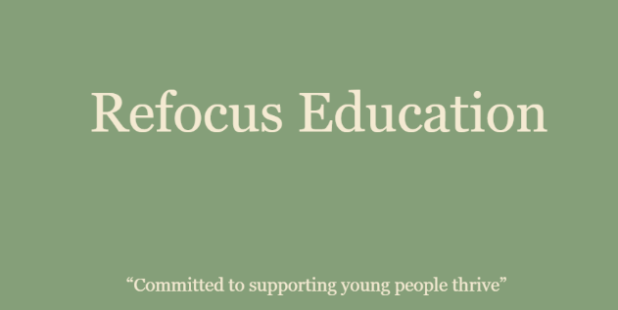
Date: June2026
Review: June2027
Reviewed by: Gary Vaughan

Reviewed by: DSL

Privacy Notice (How we use children’s information)
The categories of children’s information that we collect, hold and share include:
- Personal information (such as name and address)
- Characteristics (such as ethnicity, language, nationality and free school meal eligibility)
- Attendance information (such as sessions attended, number of absences and absence reasons)
- Relevant medical information
- Children’s assessment data (such as test results, assessments, half termly reports)
- Information about additional education interventions carried out by the commissioning school
- Information about any special educational needs children may have
- Logs of behavioural incidents

Why we collect and use this information
We use the children’s data:

- to support children’s learning
- to monitor and report on children’s attainment progress
- to provide appropriate pastoral care
- to assess the quality of our services
- to keep children safe (food allergies, or emergency contact details)
- to meet the statutory duties placed upon us under GDPR

The lawful basis on which we use this information
We collect and use children’s information under the following bases (in our role of collectors of data we are known as the ‘Data Controller’):
“processing is necessary for the performance of a task carried out in the public interest or in the exercise of official authority vested in the controller” - GDPR Article 6(1)(e)
“processing is necessary for compliance with a legal obligation to which the controller is subject – GDPR Article 6(1)(c)”
“processing is necessary for reasons of substantial public interest, on the basis of Union or Member State law which shall be proportionate to the aim pursued, respect the essence of the right to data protection and provide for suitable and specific measures to safeguard the fundamental rights and the interests of the data subject” - GDPR Article 9(2)(g)

Collecting children’s information
Whilst the majority of children’s information you provide to us is mandatory, some of it is provided to us on a voluntary basis. In order to comply with the General Data Protection Regulation, we will inform you whether you are required to provide certain information to us or if you have a choice in this.

Storing children’s data
Children’s data is stored securely at school using a database called Learntrek. Data is only accessible to those authorised to view it (see Data Protection Policy – available on the Refocus Education website).
Academic and administrative records are retained in line with the data retention schedule which can be found as Appendix 2 of our Data Protection Policy. Special Educational Needs files, reviews and Individual Education Plans are kept until 25 years after the Date of Birth of the child.
Photographs are only taken for identification purposes and are stored securely on the Learntrek database only with parent’s permission. These photos are retained after pupils have left our agency for historical and archiving purposes in the public interest.
We will not publish any children’s photos in the public domain.

Who we share children’s information with
We routinely share children’s information with:

- commissioning schools that the children attend or a new school after leaving us
- our local authority

Other instances where we may share information:

- We may need to share information about children’s health and wellbeing with the School Nurse
- We may need to share information with the police or our legal advisers if something goes wrong or to help with an inquiry
- We sometimes use contractors to handle personal information on our behalf. The following is an example:
- We use third party "cloud computing" services to store information.

Why we share children’s information
We do not share information about our children with anyone without consent unless the law and our policies allow or require us to do so.
We are required to share information about our children with our local authority (LA) under section 3 of The Education (Information About Individual Pupils) (England) Regulations 2013.

LearnTrek Communications
As an agency, it is part of our statutory duty to provide and communicate information about their child’s education to parents. To this end, we share primary contact information with LearnTrek (https://www.lerntrek.co.uk ). This allows us to quickly and effectively contact parent/carers via Email.

Requesting access to your personal data
Under data protection legislation, parents and children have the right to request access to information about them that we hold. To make a request for your personal information, or be given access to your child’s educational record, contact admin@refocuseducation.co.uk

You also have the right to:
- object to processing of personal data that is likely to cause, or is causing, damage or distress
- prevent processing for the purpose of direct marketing
- object to decisions being taken by automated means
- in certain circumstances, have inaccurate personal data rectified, blocked, erased or destroyed
- claim compensation for damages caused by a breach of the Data Protection regulations
If you have a concern about the way we are collecting or using your personal data, we request that you raise your concern with us in the first instance. Alternatively, you can contact the Information Commissioner’s Office at https://ico.org.uk/concerns/
Contact
If you would like to discuss anything in this privacy notice, please contact our Data Protection Officer (Gary Vaughan) via our admin email: admin@refocuseducation.co.uk

